Name:T.Mohana
HallTicket:2303A52446 Batch: 41
Task 1:Employee Dataset Cleaning Prompt:
Cleanandpreprocessanemployeedataset (ID, name,designation, salary, experience,employmenttype)byhandling missingvaluesinsalary,designation,andexperience,removingduplicates,standardizingtexttolowercase,and encoding categoricalvariables. Output a clean dataset ready for HRanalytics.
DataSetCreation:
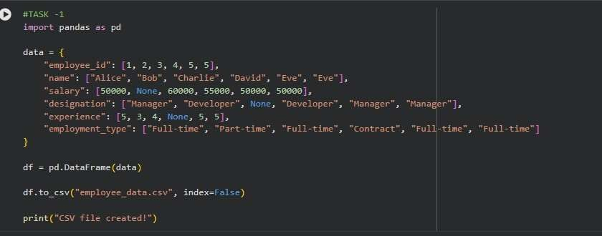
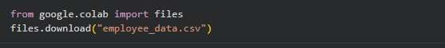

Code:

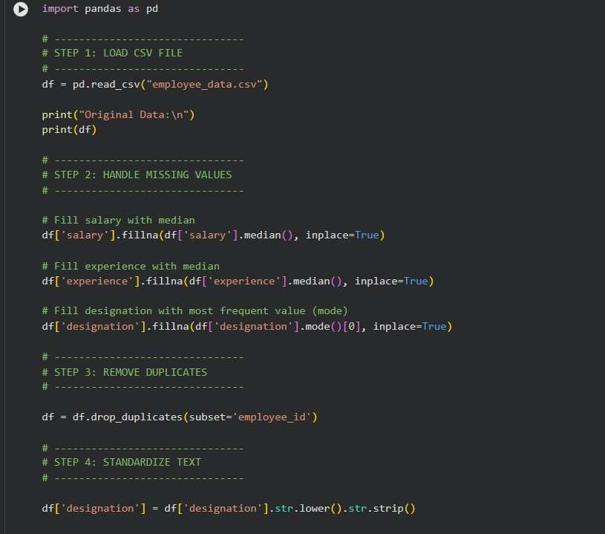
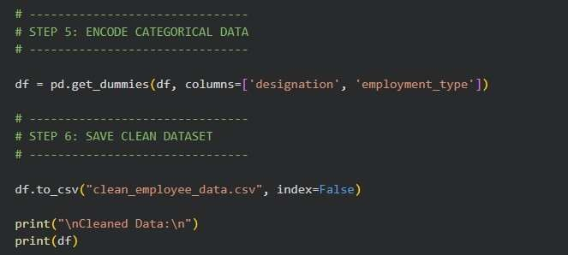

Output:
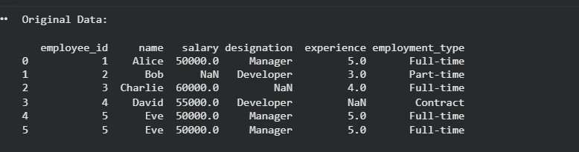

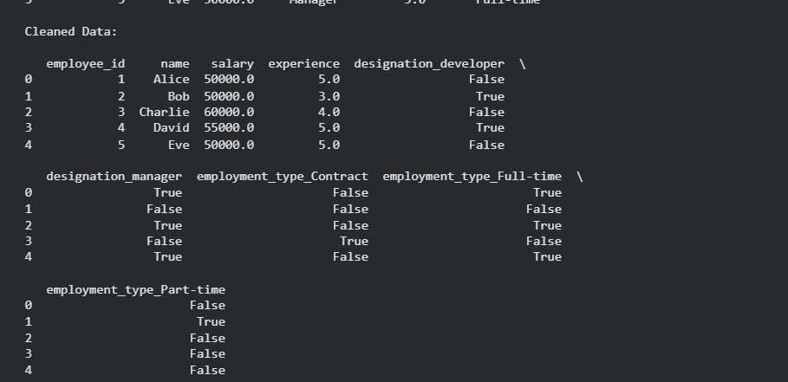
Explanation:
Employeedatasetsoftencontainmissingvalues,duplicates,andinconsistentformats.Cleaningensuresdata accuracyandreliability.Handlingmissingvaluesprevents lossofimportantinformation.Removing duplicates avoids redundancyandincorrectanalysis.StandardizingandencodingdatamakesitsuitableforHRanalyticsandmachine learning models
Task2:StudentPerformanceDataPreprocessing Prompt:
Preprocessastudentperformancedatasetbyconvertingexam_datetodatetime,extractingfeatureslikemonth,day,or semester,normalizingtotal_marks,andhandlingoutliersusingIQRorZ-score.Outputaclean,transformeddatasetready for analysis.
DataSetCreation:
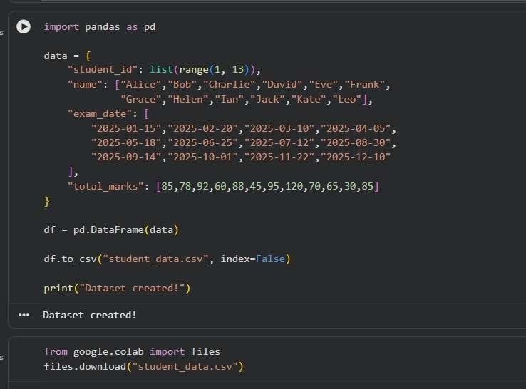

Code:
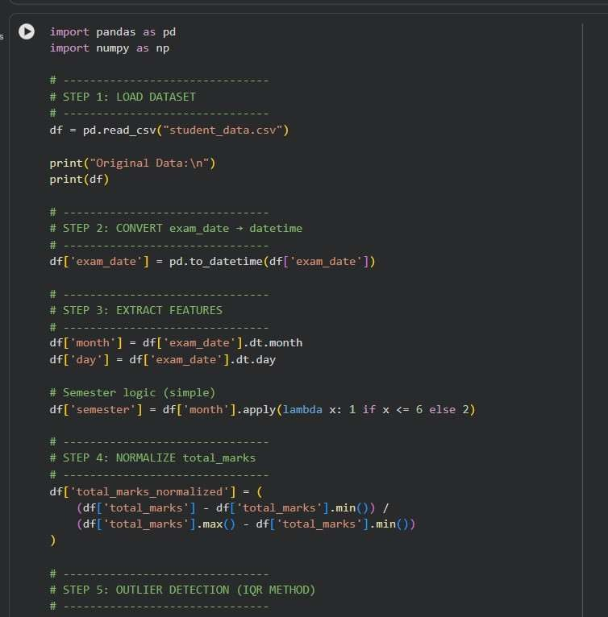
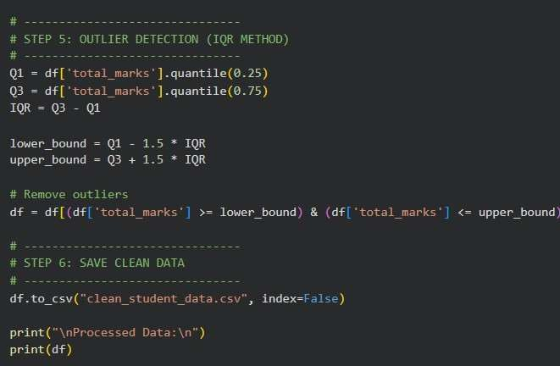

Output:
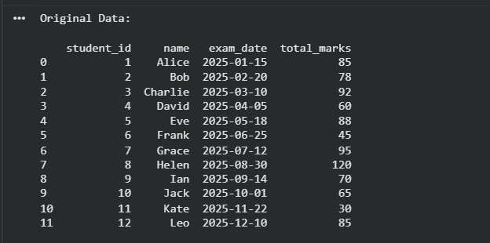
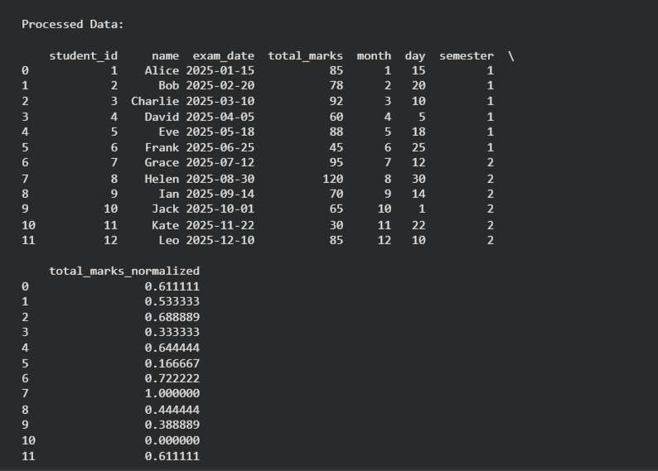

Explanation:
Student performancedataincludes time-basedandnumericalattributesthatneedtransformation.Convertingdates intodatetimeformatenablesextractionofusefultemporalfeatures.Normalizingmarksensuresuniformscalingfor better analysis. Handling outliers preventsskewed results. These steps improvedata quality for accurate predictions and insights.
Task3:StudentHealthDataPreparation Prompt:
Cleanandpreprocessastudenthealthdatasetbyhandlingmissingvaluesinheight,weight,andBMI,encoding categorical variables(medical_condition,fitness_status),scaling numericalfeatures,andsplittingintotrainingand testing sets. Output a dataset ready for predictive analysis.

DataSetCreation:
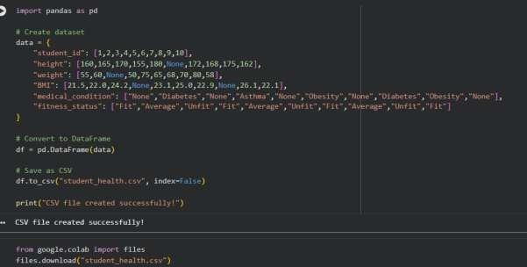
Code:
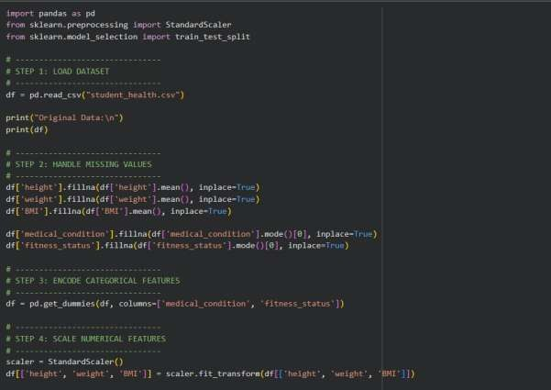
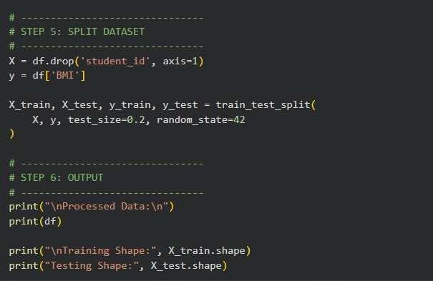

Output:
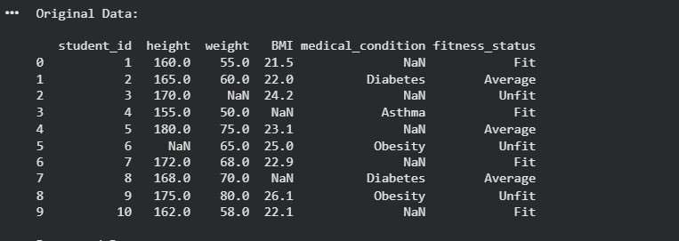
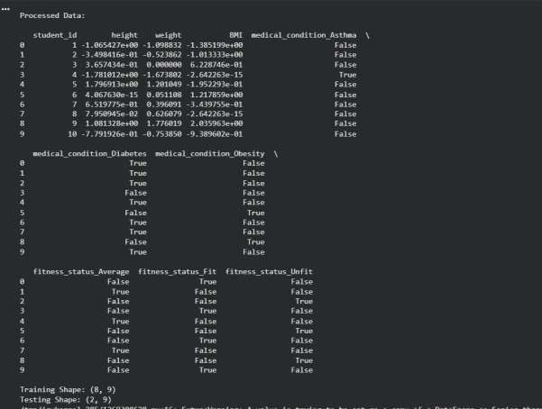

Explanation:
Studenthealthdatasetsmaycontainmissingvaluesandcategoricalattributes.Handlingmissingdataensures completenessandavoidsbias.Encodingcategoricalvariablesconvertsthemintonumericalformformodelusage. Scalingnumericalfeaturesensures faircontributionofall variables.Splitting datahelps evaluate modelperformance effectively.
Task4:Ride-SharingDataCleaning Prompt:
Cleanandpreprocessaride-sharingdatasetbystandardizingpickupanddroplocations,fillingmissingfarevalueswiththe median, removingduplicates, normalizingdriverratings,andsummarizing dataimprovements. Outputacleandataset ready for analysis and decision-making.

DataSetCreation:

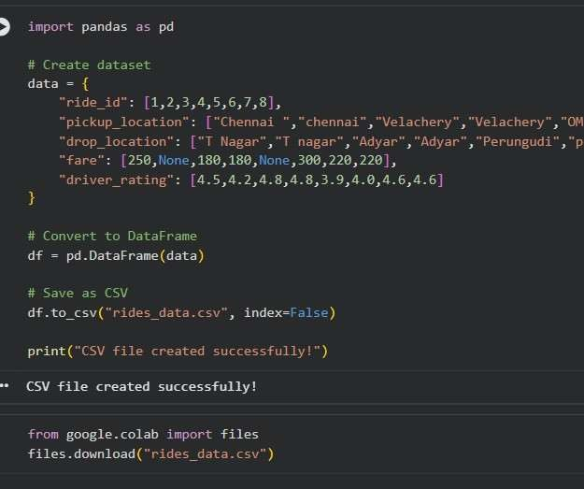
Code:
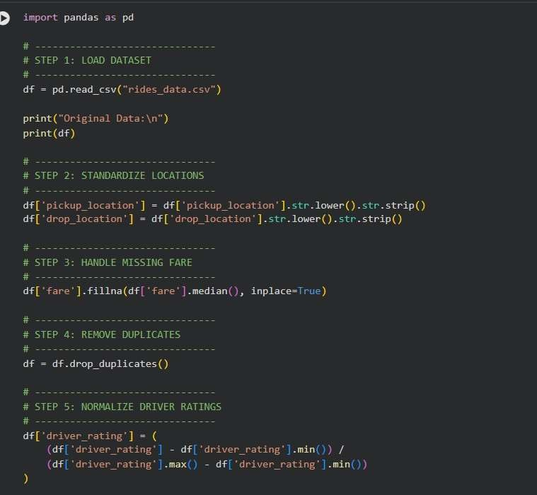
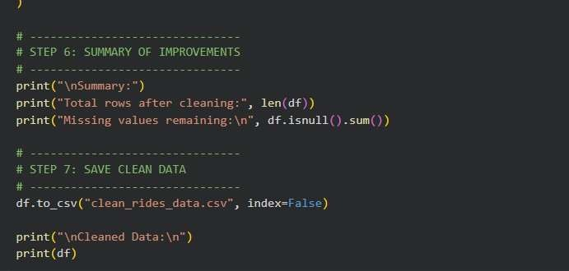

Output:
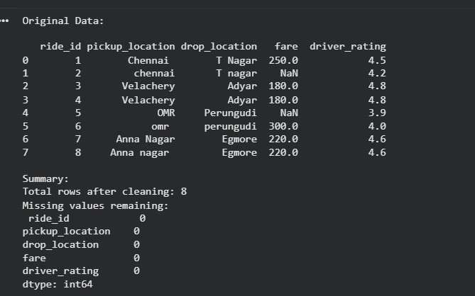
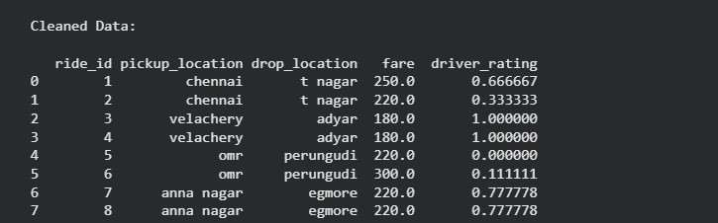

Explanation:
Ride-sharingdatasetsoftencontaininconsistenttext,missingvalues,andduplicates.Standardizinglocationnames ensures uniformityinanalysis.Fillingmissingfarevaluesusingmedianmaintainsdata integrity. Removingduplicates avoids redundancy in records.
Normalizingratingsensuresconsistentcomparisonandimprovesdataqualityforanalysis.

